**INSTITUTE OF ENGINEERING**

ADVANCED COLLEGE OF ENGINEERING AND MANAGEMENT

Kupondole, Lalitpur

**(AFFILIATED TO TRIBHUVAN UNIVERSITY)**



Lab no:8

Subject: Computer Network

**Submitted By: Submitted To:**

Department of Computer

and

Electronics Engineering

Name: Sameep Dhakal

Roll no: ACE074BCT063

Date: 09/07/2021

# Lab 8

# Title: Multiuser Connection

# Objective:

* To learn about configuration of multiuser connection

# Theory:

The multiuser feature in Packet Tracer allows multiple point-to-point connections between multiple instances of Packet Tracer. This first Packet Tracer Multiuser (PTMU) activity is a quick tutorial demonstrating the steps to establish and verify a multiuser connection to another instance of Packet Tracer within the same LAN. Ideally, this activity is meant for two students. However, it can also be completed as a solo activity simply by opening the two separate files to create two separate instances of Packet Tracer on your local machine.

# Design: Open Multiple Cisco Packet Tracer and draw the same structure as client-side and Server-side drawings on different cisco packet tracer windows

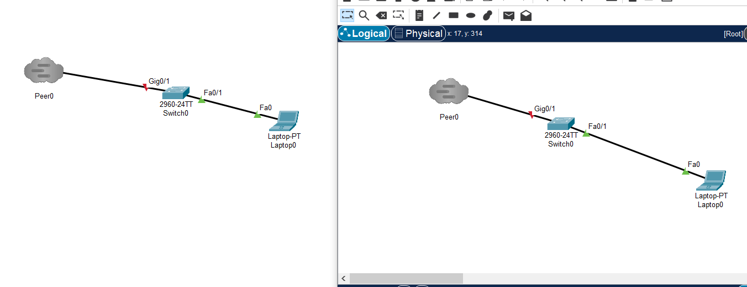

# Procedure:

* Client-Side Multiuser Connection
* First the required tools are selected.
* Specify the connection type as Outgoing, Peer Network Name as **Peer 0** (it is case sensitive).
* Specify the password as **721108**
* Then click on **Connect** to display **Peer 0** in another terminal of Cisco Packet Tracer
* Click on **Yes** to Display **Peer 0** multiuser peer connection to another cisco packet tracer window.
* Configure Ip address with subnet mask along with gateway
* Server-Side Multiuser Connection
* First the required tools are selected.
* When you get **Peer 0** on Screen
* then connect the wire manually from gigabit port of the Switch to **Peer 0** Click on Link 0(Switch 0 GigabitEthernet0/1) to make connection establish.
* Now you can ping from any terminal to the other packet tracer user.
* Configure Ip address with subnet mask along with gateway

# Output:

* Ping from Client to Server

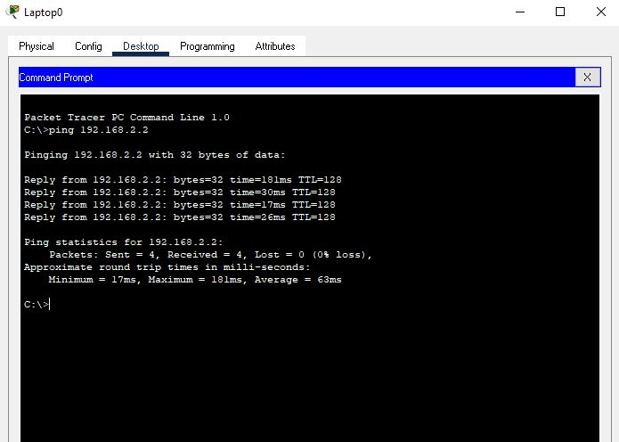

# Result and Conclusion:

In this lab we were able to configure the multiuser connection in the devices and able to ping them without any physical connection.